### Installing Heka on Windows

**1、 Download the installation package**

### Upload the Windows Heka installation package to the Windows server;

#### 2、 Install Heka (requires administrator privileges)

**2.1 Double click installation package**

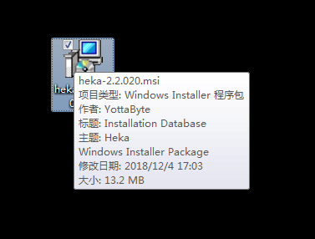

2.2 Click on "next"

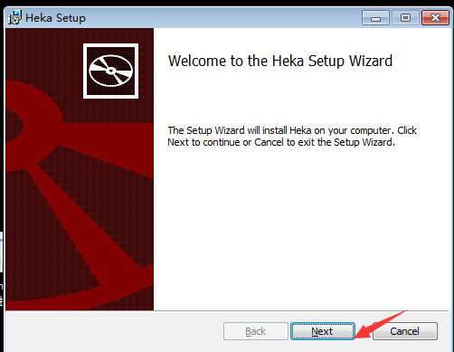

2.3 Select the "installation directory"

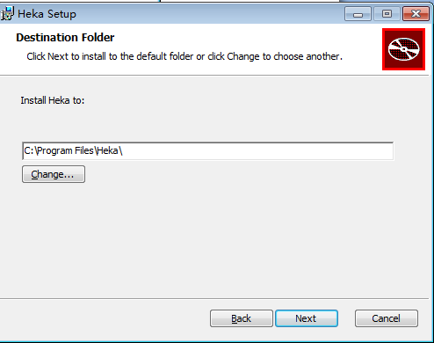

**2.4 Click "OK"**

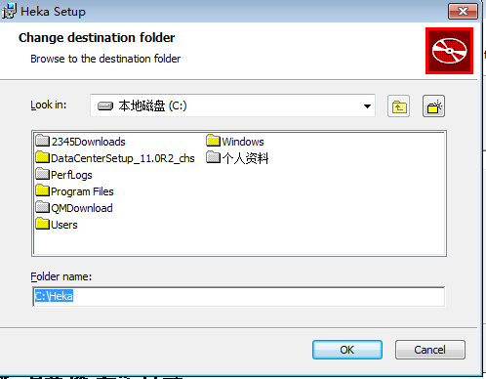

**2.5 After confirming the installation directory, click "next"**

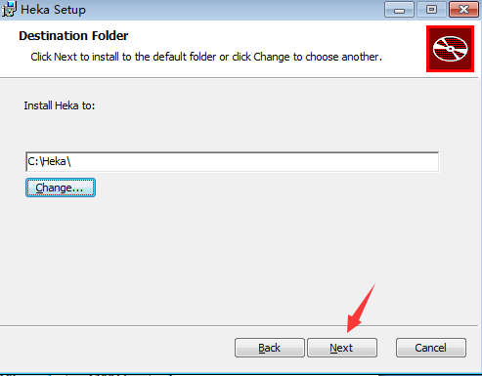

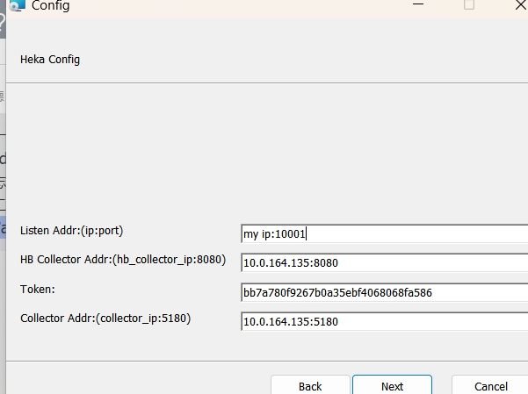

Notes:

Host IP:10001 （Listen Addr port）

10.0.164.135:8080 （frontend ip port）

bb7a780f9267b0a35ebf4068068fa586（token）

10.0.164.135:5180 （collector ip port）

1）Listen Addr: The host IP address for install this client, port recommendation is to use 10001

2）frontend_IP: Frontend address, please fill in 10.0.164.135:8080

3）Token: Fixed value, please fill in bb7a780f9267b0a35ebf4068068fa586

4) collector_IP:The address of the collector, 10.0.164.135:5180

**2.6 Click on "Next"**



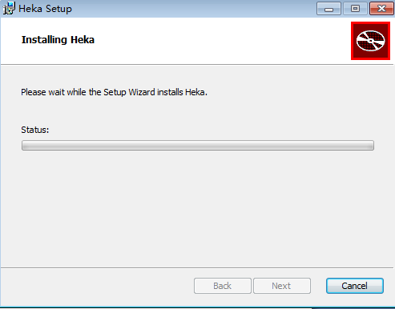

#### 2.7 Click on "finish"

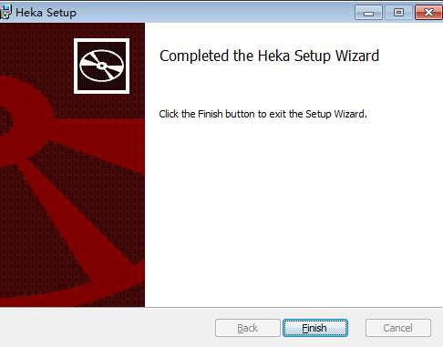

### 3、 Verify if the installation was successful

Open the command prompt and enter "netstat - an | find" 10001

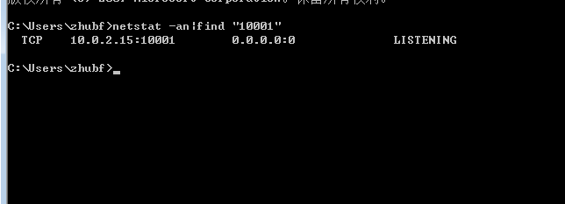

Alternatively, select "Computer", right-click on "Manage", and then select "Services"

